**Intermediate Designs**

# **User Persona:**

**Name:** Sara Malik  
 **Age:** 24  
 **Occupation:** University Student  
 **Location:** Lahore, Pakistan  
 **Devices Used:** Android phone, Laptop

**Goals:**

* Order affordable meals quickly between classes
* Get personalized restaurant suggestions

**Frustrations:**

* Complicated checkout process
* Long delivery times or no real-time tracking

**Behaviors:**

* Uses app during short breaks
* Prefers cash on delivery
* Orders mostly from nearby restaurants

**Favorite Apps:**

* Foodpanda, WhatsApp, TikTok

# **User Flow:**

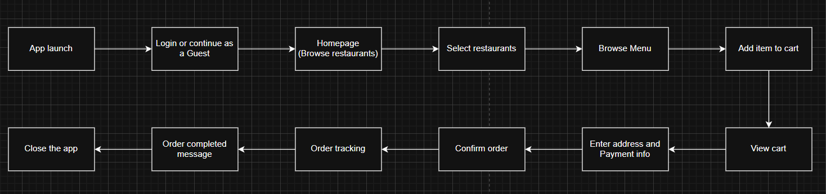

**3 Core Pages to Wireframe:**

**Page 1:**

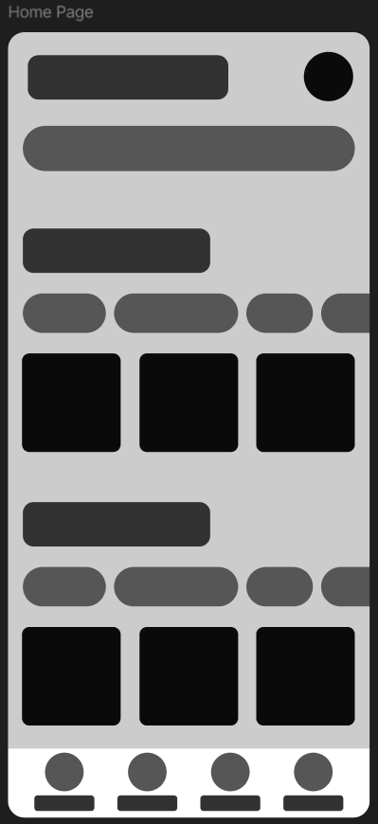

**Page 2:**

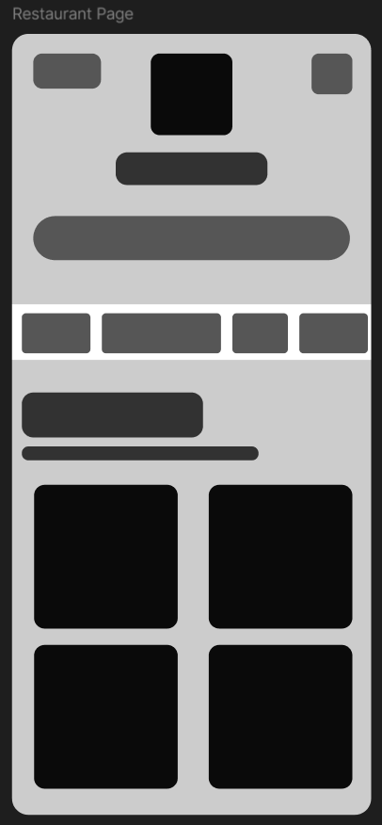

**Page 3:**

